Trade File Management — Combined Technical + Functional Documentation
Version: 1.1
Date: March 9, 2026
Scope: Frontend (Angular) using mock services today; ready for Spring Boot + JWT backend.

1. Executive Summary
This Angular application enables trade file upload, listing, search, detail view, and status updates.
Today: all data is simulated via mock services with persistence in localStorage.
Target: replace mocks with real HTTP APIs, JWT authentication, and secure data handling without major UI changes.
Why this doc?
- Backend: Provides endpoint contracts, payload schemas, paging structure, and status transitions expected by the UI.
- Security: Details current localStorage behavior, target JWT strategy, CORS, token storage, RBAC, logging, and risk items to fix before production.

2. High-Level Architecture
- Frontend (Angular with NgModules)
  - Components (Upload, List, Search, Details, Login, Dashboard, Navbar, Footer)
  - Services: AuthService (mock), FileLoadService (mock)
  - Storage: localStorage keys fl_user (session) and fl_mock_db (mock DB)
- Future Backend (Spring Boot)
  - Auth (JWT), File CRUD & Search
  - DB (relational) + object/file storage
  - OpenAPI/Swagger for contract clarity

Architecture Diagram
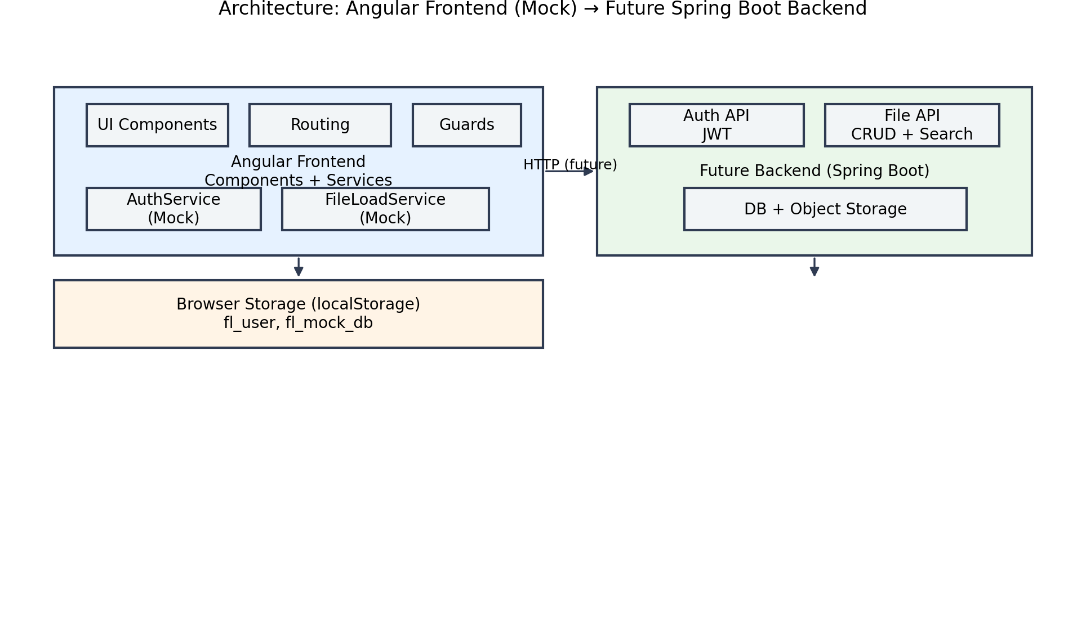
3. Actual Frontend Structure
file-load-ui
│
├── .angular
├── .idea
├── node_modules
│
├── src
│ ├── app
│ │ ├── components
│ │ │ ├── dashboard
│ │ │ ├── file-details
│ │ │ ├── file-list
│ │ │ ├── file-search
│ │ │ ├── file-upload
│ │ │ ├── footer
│ │ │ ├── login
│ │ │ ├── navbar
│ │ │ │ ├── navbar.component.html
│ │ │ │ ├── navbar.component.scss
│ │ │ │ └── navbar.component.ts
│ │ │ ├── register
│ │ │ └── status-update
│ │ │
│ │ ├── guards
│ │ ├── models
│ │ ├── services
│ │ │
│ │ ├── app.component.html
│ │ ├── app.component.scss
│ │ ├── app.component.ts
│ │ ├── app.module.ts
│ │ └── app-routing.module.ts
│ │
│ ├── assets
│ ├── environments
│ │
│ ├── index.html
│ ├── main.ts
│ └── styles.scss
│
├── angular.json
├── package.json
├── package-lock.json
├── tsconfig.app.json
└── tsconfig.json

4. Functional Overview (Screens & Behaviors)
- Login (mock) → validates against local fake users; stores session in fl_user.
- Dashboard → post-login landing.
- Upload → select file; mock progress; record appended to mock DB.
- File List → MatTable + paginator + sort; integrates search.
- Search → by filename, status, date range.
- Details → view metadata; update status; delete; archive.
- Status Update → MatDialog to set new status; validates transitions on client (basic).

5. Key Application Flows
5.1 Login Flow (Mock)
- AuthService checks credentials against fl_mock_db.users.
- On success → write fl_user to localStorage → redirect to /dashboard or /upload.
- Navbar shows protected links when session exists.

Login Flow
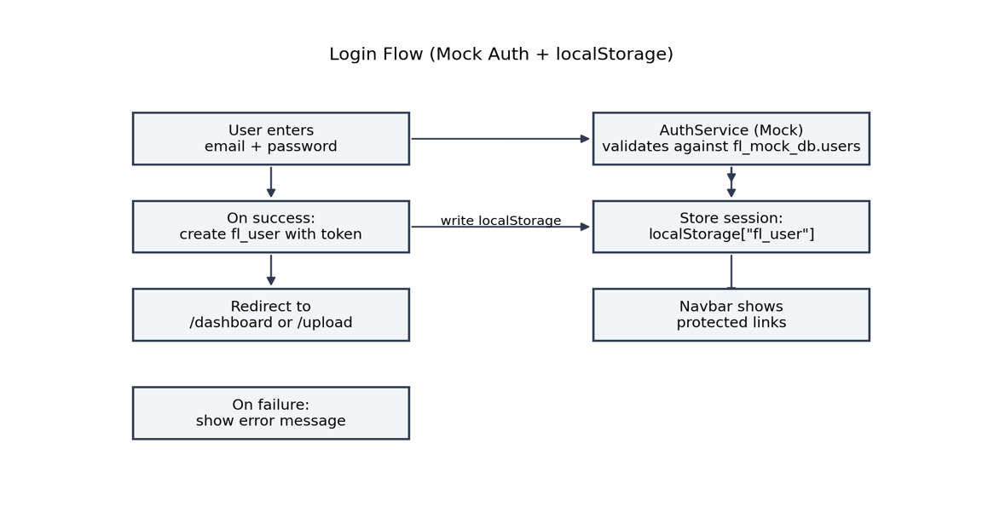

5.2 File Lifecycle (Mock)
- Upload view triggers FileLoadService (fake delay).
- New FileItem appended to fl_mock_db.files.
- List/Search/Details read from the same store.
- Status changes, delete, and archive mutate mock DB.
File Lifecycle
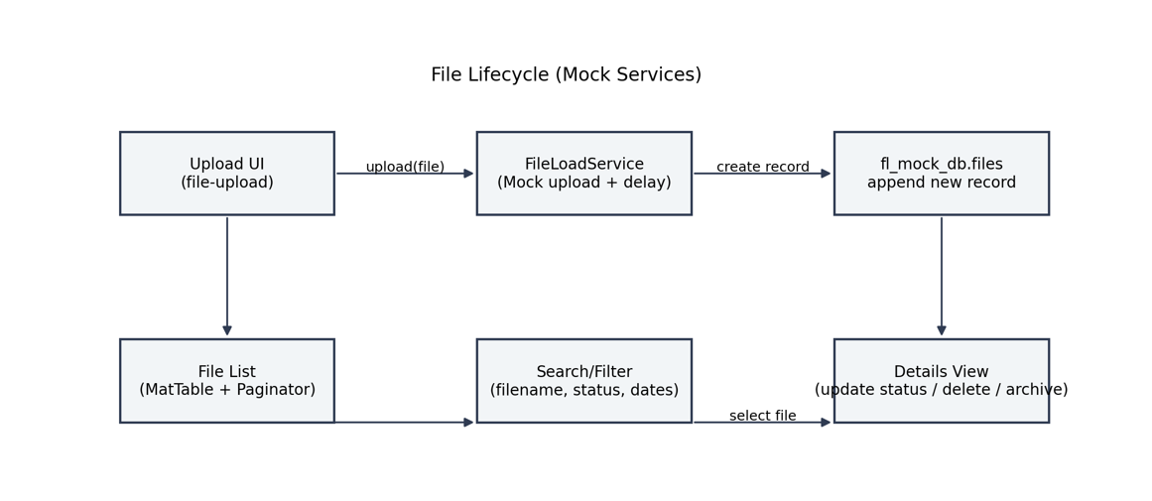
6. Local Storage (Current Behavior)
Keys present in your environment:
fl_user (current session)
{
"id": "u_2",
"name": "User",
"email": "user @gmail.com",
"token": "mock-token-u_2"
}
fl_mock_db (mock database: users, files, lastIds)
{
"users":[{"id":"u_1","name":"Demo User","email":"demo@example.com","password":"password","token":"mock-token-u_1"},
{"id":"u_2","name":"Anmol","email":"anmoltiwari621@gmail.com","password":"123456","token":"mock-token-u_2"}],
"files":[{"id":"f_1","name":"Report.pdf","size":124567,"mimeType":"application/pdf",
"uploadedBy":"Demo User","uploadedAt":"2026-03-07T19:18:40.872Z","status":"COMPLETED",
"description":"Quarterly report","tags":["finance","Q1"],"version":1,"checksum":"abc123"}],
"lastIds":{"user":2,"file":3}
}

Security note (mock-only): Raw passwords and tokens are visible in fl_mock_db.
Must be removed when switching to real backend.

7. Frontend Data Models (Exact from Code)
// file-load.model.ts
export type FileStatus = 'PENDING' | 'PROCESSING' | 'COMPLETED' | 'FAILED';

export interface FileItem {
id: string;
name: string;
size: number;
mimeType: string;
uploadedBy: string; // CONFIRMED: will be the USER ID with real backend
uploadedAt: string; // ISO date-time
status: FileStatus;
description?: string;
tags?: string[];
checksum?: string;
version?: number;
}

export interface PagedResult<T> {
items: T[];
total: number;
page: number;
pageSize: number;
}
uploadedBy will be user ID (e.g., "u_2"), not display name.

8. Proposed REST API Contracts (Target Backend)
Designed so the UI needs minimal code changes when mocks are replaced.
8.1 Authentication
POST /api/auth/login
Request
{ "email": "user@example.com", "password": "******"
Response 200
{ "token": "<jwt>", "user": { "id": "u_2", "name": "Anmol", "email": "user@example.com", "role": "USER" } }
Errors → 401, 429
POST /api/auth/register (optional for prod)
Request { "name": "...", "email": "...", "password": "..." }
Response 201 { "id": "u_3", "name": "...", "email": "..." }
Errors → 409
POST /api/auth/refresh
Request { "refreshToken": "<token>" }
Response 200 { "token": "<new-jwt>" }

8.2 File APIs
POST /api/file-loads/upload (multipart/form-data)
Parts
- file (binary)
- description (string, optional)
- tags (string[], optional)
Response 201 (FileItem)
{
"id":"f_123",
"name":"Report.pdf",
"size":124567,
"mimeType":"application/pdf",
"uploadedBy":"u_2",
"uploadedAt":"2026-03-09T05:05:00Z",
"status":"PENDING",
"description":"Q1 report",
"tags":["finance","q1"],
"checksum":"<sha256>",
"version":1
}

Errors → 400, 413, 415
GET /api/file-loads
Query page, pageSize, sort, filename, status, fromDate, toDate
Response 200 (PagedResult)
{
"items": [ FileItem, ... ],
"total": 120,
"page": 0,
"pageSize": 20
}
GET /api/file-loads/{id}
Response 200 → FileItem ; 404 if not found
PATCH /api/file-loads/{id}/status
Request
{ "status": "COMPLETED" }

Response 200 → updated FileItem
DELETE /api/file-loads/{id}
Response 204
POST /api/file-loads/{id}/archive
Response 200 → updated FileItem with "status":"ARCHIVED" (UI can map to final state or show as a badge even if not in FileStatus union; or extend union to include 'ARCHIVED' if required.)
Note: Current UI union type does not include 'ARCHIVED'.
Two options:
- Option 1 (preferred): Add 'ARCHIVED' to FileStatus.
- Option 2: Keep FileStatus as-is; treat archive as delete or as a separate flag in backend; UI shows “Archived” badge read-only.
Please confirm which option you prefer. Until then, API example retains ARCHIVED as a backend state.

9. Routing (UI)
/login -> LoginComponent
/register -> RegisterComponent
/dashboard -> DashboardComponent
/upload -> FileUploadComponent
/files -> FileListComponent
/files/:id -> FileDetailsComponent
Planned Guards: AuthGuard for everything except /login and /register.
10. Status Model & Transitions
- PENDING → PROCESSING → COMPLETED | FAILED
- Any → ARCHIVED (admin only) (subject to decision in Section 8.2 note)
Backend responsibility: enforce state machine; UI will display backend error messages for invalid transitions.
11. Pagination, Sorting, Filtering (Contract)
- Server-side paging: page, pageSize
- Sorting: sort=uploadedAt,desc (or name,asc)
- Filters:
  - filename: partial match
  - status: exact match (PENDING|PROCESSING|COMPLETED|FAILED)
  - fromDate, toDate: ISO (inclusive)
12. Frontend → Backend Migration Plan
- Replace internals of AuthService / FileLoadService with HttpClient calls.
- Add AuthInterceptor to attach Authorization: Bearer <jwt>.
- Introduce AuthGuard to routing.
- Remove fl_mock_db usage entirely. Keep only minimal session (token, id, name, email) in memory or localStorage.
- Add global HTTP error handling (e.g., interceptor) to map server errors to Material SnackBars/dialogs.
13. Security Requirements (Target State)
- Transport: HTTPS only.
- Auth: JWT Bearer; access token short-lived (≈15 minutes), refresh via HTTP-only cookie or secure store.
- Client Storage:
  - Prefer in-memory access token; if localStorage is used, ensure no PII beyond { id, name, email } and the token.
  - Do not store raw passwords anywhere client-side.
- CORS: restrict to known origins; allow Authorization; refuse wildcard with credentials.
- Rate limiting: on /auth/login and upload endpoints.
- File Validation: size, MIME allow-list, server-side checksum, optional malware scan.
- RBAC: at least USER and ADMIN; admin for delete/archive/status override.
- Audit Logs: uploads, status changes, deletes, and all auth events.
- Headers: CSP, HSTS, X-Content-Type-Options, Referrer-Policy.
- Error Responses: consistent envelope without leaking internal details.

14. Error Envelope (Recommended)
{
"timestamp": "2026-03-09T05:15:00Z",
"status": 400,
"error": "Bad Request",
"message": "Unsupported file type",
"path": "/api/file-loads/upload",
"code": "FILE_UNSUPPORTED_TYPE"

15. Configuration
environment.ts example:
export const environment = {
production: false,
apiBaseUrl: 'http://localhost:8080/api'
};

Build:

npm install
ng serve//npm start
# http://localhost:4200

16. Deliverables & Next Actions
For Backend Team
- Implement endpoints in Section 8 matching PagedResult format.
- Enforce state transitions and RBAC.
- Provide OpenAPI/Swagger; share apiBaseUrl.
For Security Team
- Validate token handling (storage, TTL, refresh).
- Provide CORS, headers, and CSP guidance.
- Confirm file validation and scanning approach.
- Approve error envelope and logging/audit plan.
For Frontend (me)
- Add AuthInterceptor, AuthGuard.
- Replace mocks with HTTP once APIs are available.
- Extend FileStatus to include 'ARCHIVED' if backend uses it as a state.

17. Change Log
- v1.1 (2026-03-09)
  - Confirmed uploadedBy = user ID.
  - Aligned contracts to PagedResult<T>.
  - Added PNG diagrams.
- v1.0 (2026-03-09)
  - Initial doc with mock behavior and integration plan.

📎 Diagrams (PNG)
- Architecture:
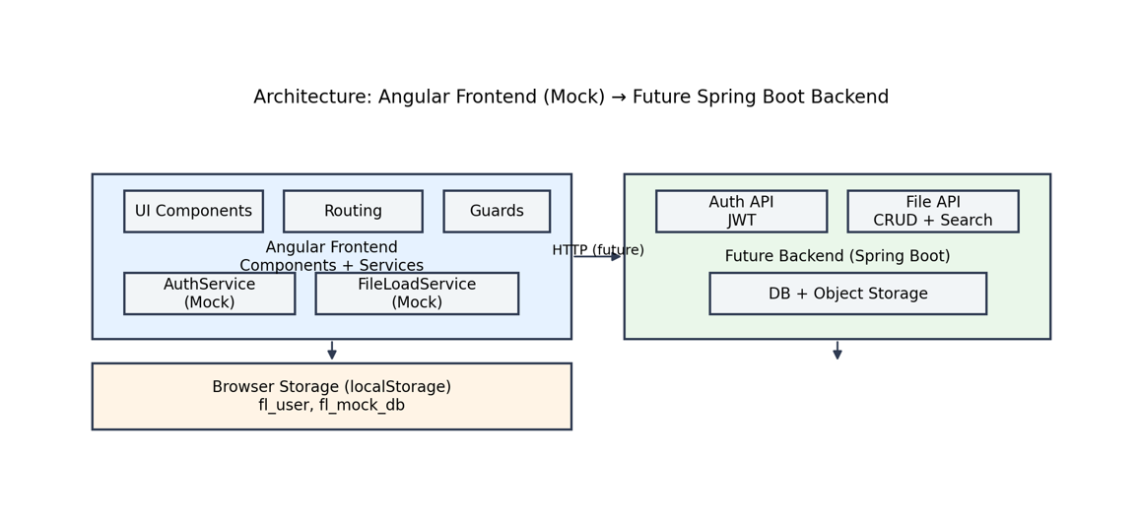

- Login Flow:
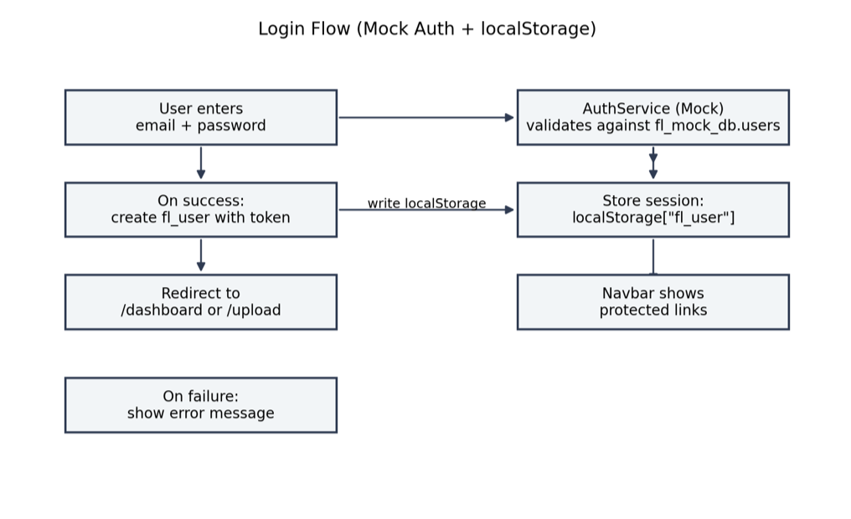

- File Lifecycle:
